Aggregate Demand

Topic 1: Determinants of aggregate demand

Difficulty Level 2
- All other things unchanged, an increase in the price level causes
  - a rightward shift of the aggregate demand curve.
  - an increase in the purchasing power of assets.
  - an upward movement along the aggregate demand curve.
  - a downward movement along the aggregate demand curve.
  - a leftward shift of the aggregate demand curve.
- Inflation causes the price level to rise in the United States. How does this inflation affect households?
  - The purchasing power of wealth increases and consumer spending increases.
  - The purchasing power of wealth decreases and consumer spending decreases.
  - The purchasing power of wealth remains constant and consumer spending remains constant.
  - The purchasing power of wealth decreases and consumer spending increases.
  - The purchasing power of wealth increases and consumer spending decreases.
- How will a decrease in price level affect the interest rate and interest-sensitive spending?
Interest Rate Interest-sensitive spending
  - Increases Increases
  - Decreases Decreases
  - Increases Decreases
  - Decreases Increases
  - Decreases Remains the same
- Aggregate demand is measured by adding together which of the following?
  - domestic spending and imports
  - domestic private consumption and government spending
  - consumption, investment, government spending, and net exports
  - savings, business inventories, profits, and net exports
  - consumption, investment, government spending, and imports
- Which of the following examples demonstrates a condition in which consumption spending would most likely increase?
  - Consumers believe their wages will be cut next year
  - The government encourages consumers to save for retirement
  - Congress passes an increase in payroll taxes
  - The price level increases
  - Changes in the stock market increases consumers’ wealth
Use the graph below to answer the following question.
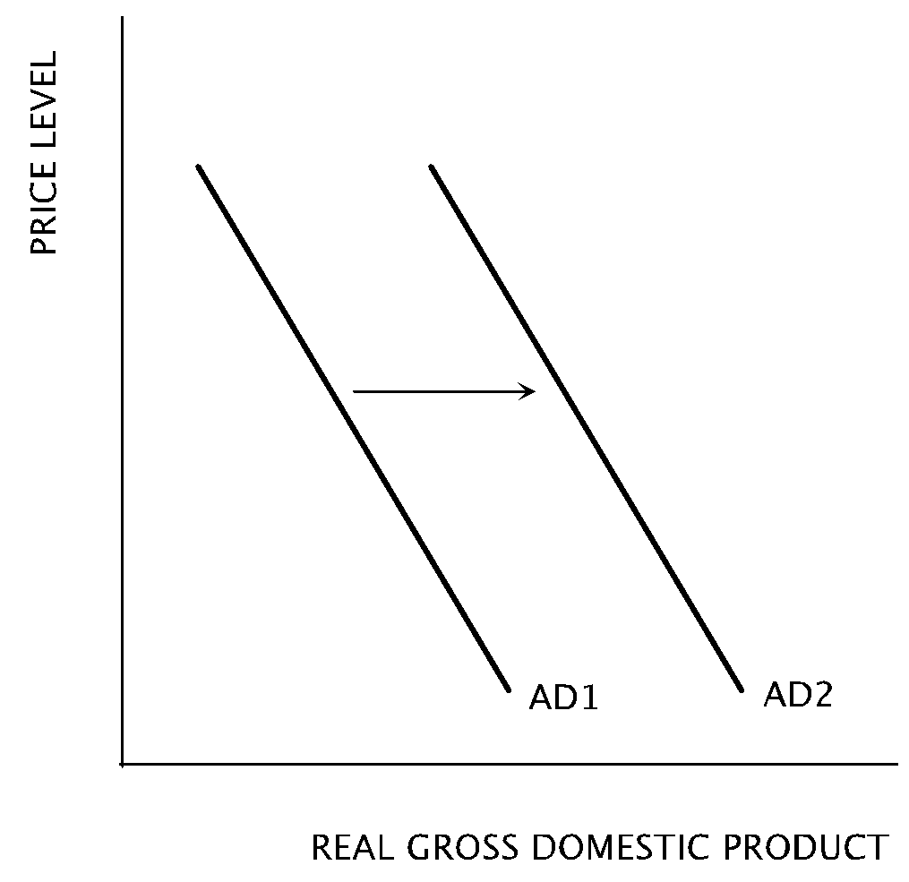
- Which of the following changes would cause an economy’s aggregate demand curve to shift from AD1 to AD2?
  - An increase in interest rates
  - An increase in consumer optimism
  - An increase in spending on imports
  - A decrease in the money supply
  - A decrease in the price level in the economy
Use the graph below to answer the following questions.
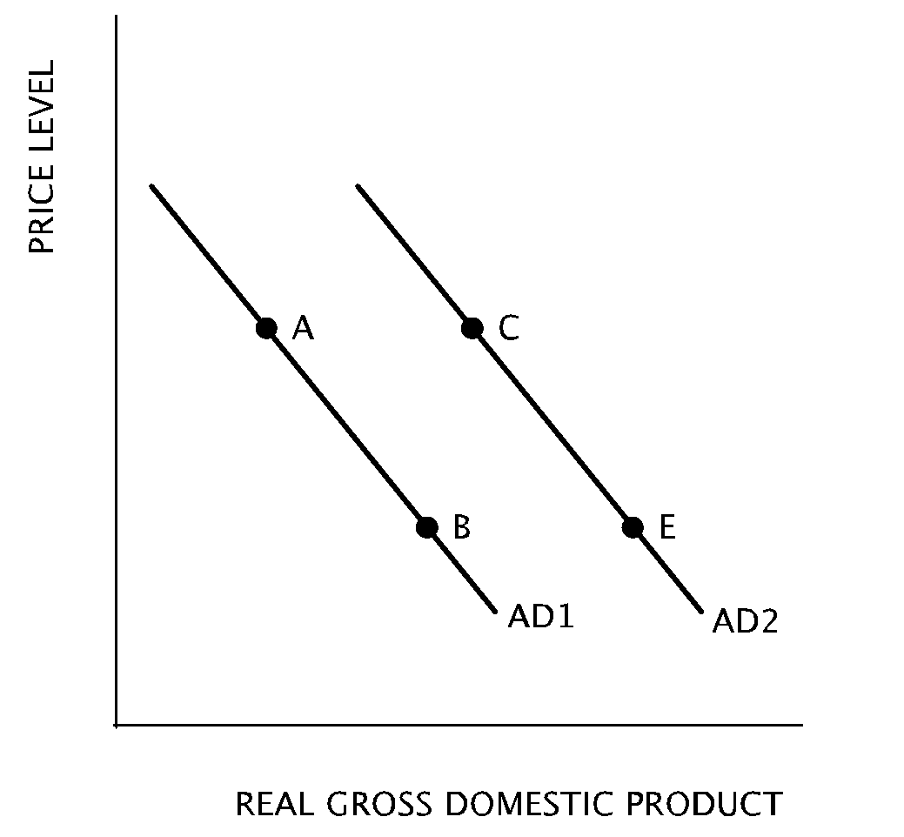
- A movement from Point A on AD1 to Point C on AD2 can be caused by which of the following changes?
  - A decrease in overall price level
  - A decrease in wealth
  - An increase in interest rates
  - An increase in overall price level
  - An increase in government purchases
- Price level is falling and consumers’ wealth and assets increase in purchasing power. Which movement on the graph best represents this change?
  - From Point E to Point C
  - From Point E to Point B
  - From Point C to Point B
  - From Point A to Point C
  - From Point A to Point B

Difficulty Level 3
- A decrease in which of the following would cause the aggregate demand curve to shift to the right?
  - Population
  - Value of the stock market
  - Labor productivity
  - Imports
  - Consumer optimism
- When the government runs a budget deficit, it increases its demand of loanable funds, crowding out private investment spending. Which movement on the graph represents the resulting increase in interest rates?
  - From Point E to Point C
  - From Point E to Point B
  - From Point C to Point B
  - From Point A to Point C
  - From Point A to Point B
Aggregate Demand
1 | C | 6 | B | 11 | A | 16 | D
2 | B | 7 | E | 12 | C | 17 | D
3 | D | 8 | E | 13 | A | 18 | D
4 | C | 9 | D | 14 | A | 19 | E
5 | E | 10 | B | 15 | C | 20 | E

